Integrated Forecasting + Distribution Network Optimization Project
Abraham Flores
San Diego State University
MIS 753 Global Supply Chain Analytics
Dr. Carlos Paternina Arboleda
15 December 2025

Introduction
Distribution network design is a critical driver of transportation performance and total landed cost within global supply chains. Firms must determine where to position distribution facilities and how many such facilities are required to balance transportation spending, service levels, and capital investment. Traditionally, these decisions rely heavily on historical demand; however, organizations increasingly require forecast network design methods to make these decisions.
This project develops a forecasting-supported center-of-gravity (CoG) framework to design a multi-depot distribution network for a U.S.-based retail dataset. The work proceeds in three stages: (1) identification of key demand drivers through historical profitability analysis, (2) development of 2018 monthly demand forecasts using Seasonal naïve and Holt–Winters models, and (3) evaluation of alternative network configurations using weighted k-means clustering with operational constraints. The analysis contributes by demonstrating how forecast network design can improve capacity planning and reduce long-term operational costs.
Methods
Data Loading and Preparation:
The raw dataset (“Final Project Global Supply Chain Clean Data.csv”) was loaded and cleaned by standardizing date formats and removing observations outside the pre-defined forecasting window. Key variables included order date, sub-category, category, profit, quantity, and postal code. The data was aggregated to monthly frequency by sub-category to produce a subcategory x month demand matrix suitable for time-series modeling and historical data.
Historical Demand Analysis:
To identify demand motives, all subcategories were ranked using total profit within the historical data 204-2017. The five most profitable categories were selected for forecasting: Phones, Chairs, Storage, Binders, and Machines. These subcategories collectively captured a significant share of total profit and exhibited consistent demand, making them strong candidates for forecasting and network planning.
Forecast Modeling:
For each of the five subcategories, monthly series were split into a training set (2014–2016) and a holdout set (2017). Two models were then evaluated:
- Baseline: Seasonal naïve forecast
- Advanced model: Holt–Winters forecast
Each model produced forecasts for 2017, which were evaluated using MAE, RMSE, and MAPE. Holt–Winters consistently outperformed the seasonal naïve baseline across almost all five subcategories. Therefore, Holt–Winters was selected as the final model for all except Chair because this subcategory produced a lower RMSE. After determining the final model, I constructed using all data from 2014–2017 to forecast the next 12 months.

Demand Scenario Construction:
- Historical demand (2014–2017): aggregated quantity per location x category
- Forecast-based 2018 demand:
  - Forecast totals for each subcategory were computed from final model predictions
  - Historical location shares (2014–2017) were applied to allocate forecasted demand geographically
  - Demand was then re-aggregated to location x category, preserving latitude, longitude, and category labels
Both matrices serve as inputs to the CoG optimization.
Multi-Depot CoG (K = 1–10):
A weighted k-means clustering routine was performed for K = 1 - 10 using
- Geographic coordinates as features
- Demand quantity as point-level weights
- Haversine distance as the transportation metric
- Furniture constraint requiring that only the Los Angeles and Houston depots serve furniture demand

For each K and each scenario, the model calculated:
- Transportation cost = Σ(distance x demand x 1$/km)
- Fixed depot cost = $8,000,000 × K
- Total cost = transportation cost + fixed depot cost
- Average and maximum distances by depot
Results & Analysis
Forecasting Results:
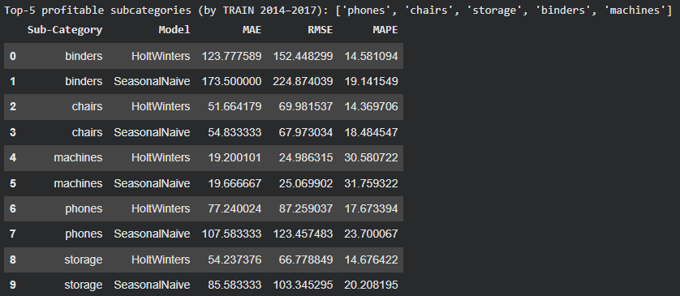
Across all subcategories except for chairs, Holt–Winters produced lower error metrics (MAE, RMSE, MAPE) than the seasonal naïve model. Chairs produced a lower RMSE which detects and penalizes large outliers. Thus, signifying that chairs had less outliers than the other subcategories. The final 2018 forecast totals were:

- Phones: ~6,137
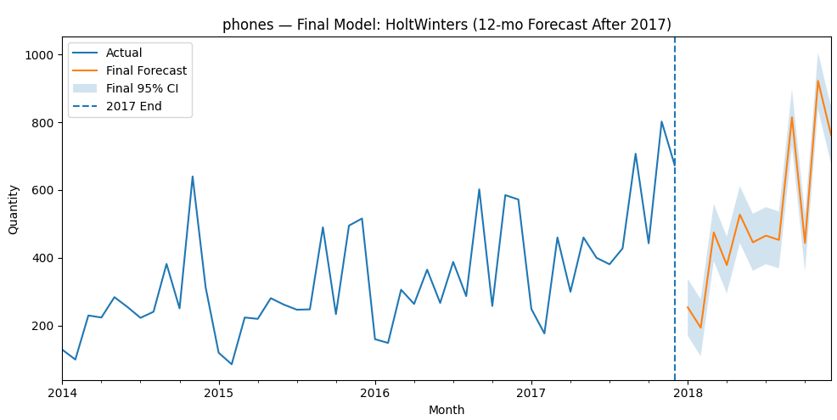
- Chairs: ~4,650
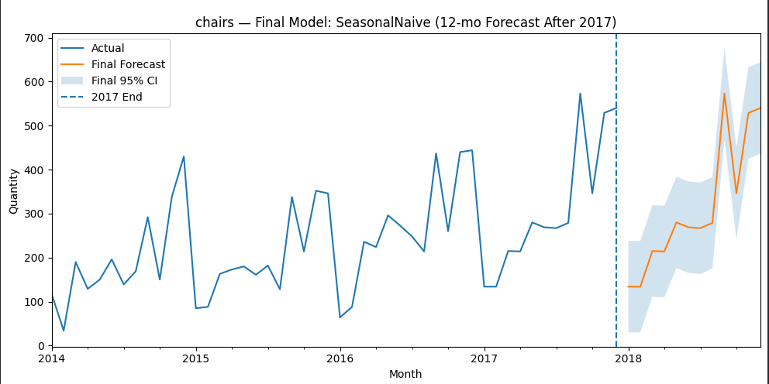
- Storage: ~5,717
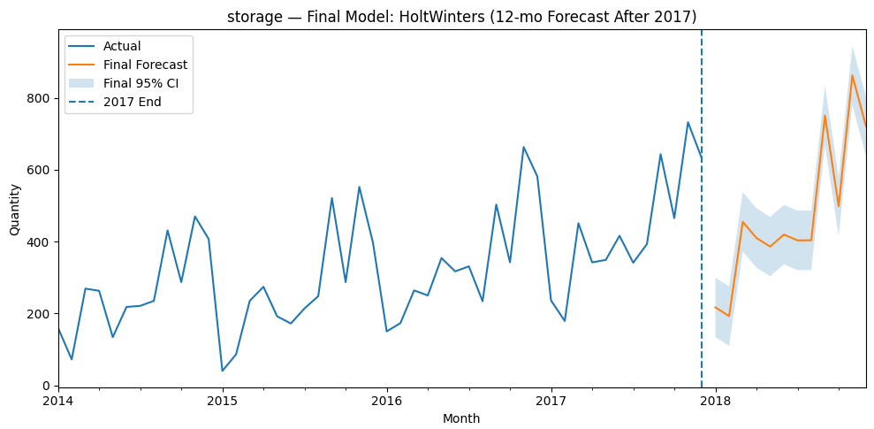
- Binders: ~11,146
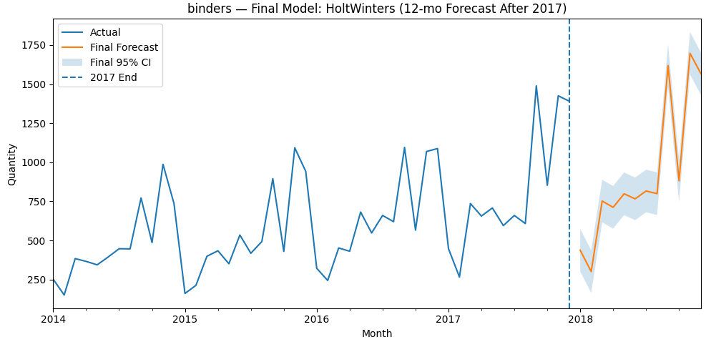
- Machines: ~774
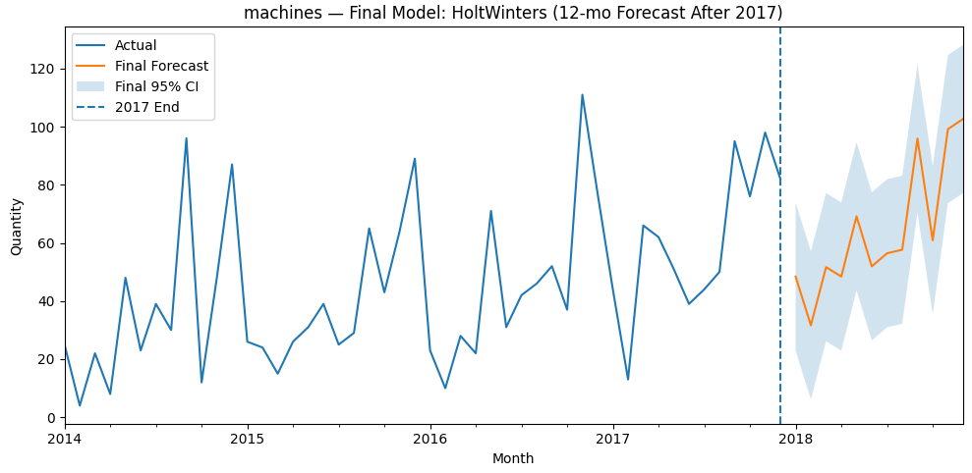
These high demand units show us not only why they are the top 5 most profitable subcategories, but that they will continue to grow in demand in 2018.
Historical CoG Scenario (2014–2017):
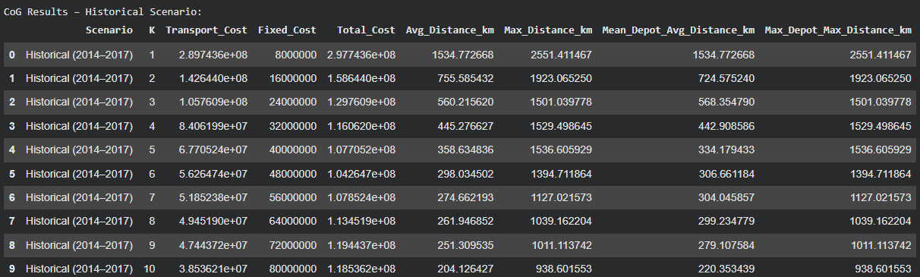
Total cost declined sharply from K = 1 to K = 4, then exhibited lower improvements.
Approximate values:
- K = 1: ~298M
- K = 2: ~159M
- K = 3: ~130M
- K = 4: ~116M
- K = 5: ~108M
- K = 6: ~105M
- K > 6: total cost began to increase
The historical optimal K lies at K = 5. Although total cost margins continue to drop to K = 6, it is unlikely that an extra depot will benefit profitability considering that it is only 3M and depot construction is 8M. Anything more than K = 6 would be absurd since total cost margins begin to increase after this point.
2018 Forecast CoG Scenario:
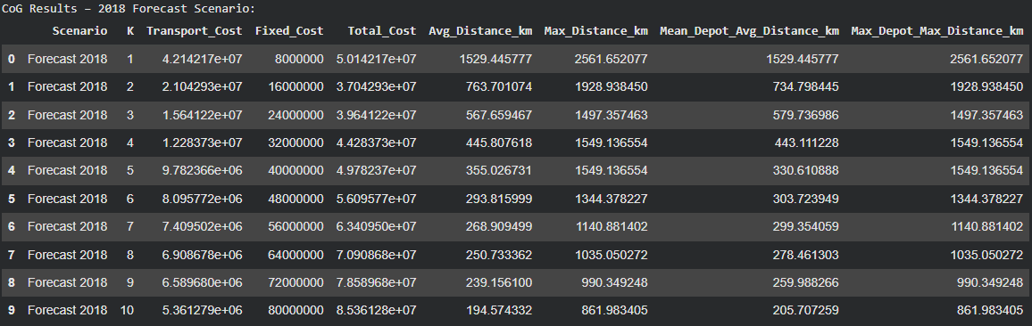
- K = 1: ~50.1M
- K = 2: ~37.0M
- K = 3: ~39.6M
- K = 4: ~44.3M
- K ≥ 5: rising steadily due to fixed cost dominating
The clear minimum occurs at:
K = 2 depots
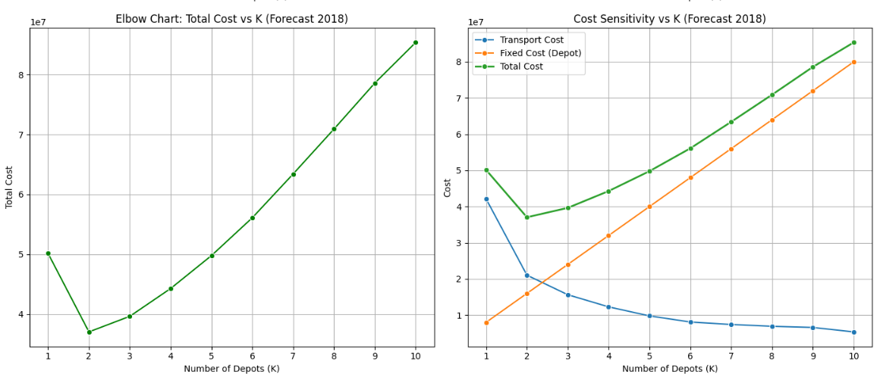
The elbow chart shows a sharp decline from K = 1 to K = 2, followed by an increase in total cost from K = 3 onward. The sensitivity chart highlights that while transportation costs continue decreasing after K = 2, the fixed cost increases outweigh these gains. The cost curve demonstrates a diminishing-returns pattern, with substantial savings achieved by adding a second depot but limited benefits. The fixed cost penalty of opening additional depots dominates the transportation savings after K = 2. Overall, the 2018 scenario supports a lean, two-depot configuration that balances service reach with cost efficiency.
Final Selection of K
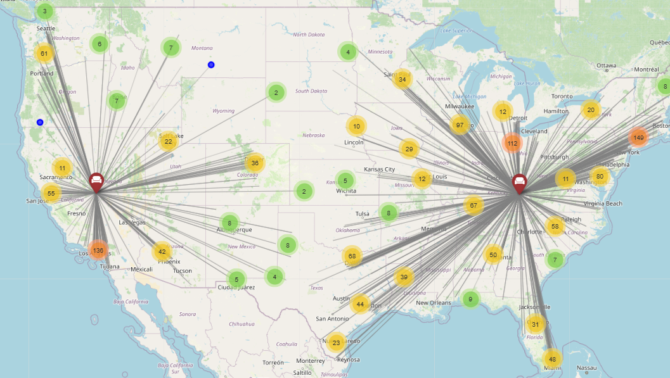
The optimal depot count is K = 2, as it minimizes total cost relative to K = 1 and avoids the steep cost increases observed for all K ≥ 3. The simplicity of a two-depot network improves operational feasibility and reduces capital expenditure risk. With the furniture constraint, Los Angeles and Houston naturally become the designated furniture-serving depots, and both are included within the K = 2 assignment. Compared to historical patterns, the optimal K in 2018 is substantially lower, indicating increased demand concentration. The stability and clarity of the cost minimum at K = 2 justify its selection for the final 2018 network design.
Extra Insights
Fairness: Maximum Distance Comparison
Fairness evaluates how evenly depots share long-distance travel. The K = 2 solution produces balanced maximum-distance values across both depots, with no extreme outliers or excessively underserved regions. Compared to K = 3 and K = 4, the two-depot network avoids isolated clusters that would otherwise be far from their assigned depots. This indicates that the selected configuration, K = 2, distributes service responsibilities equally without imposing unbalanced distance burdens on specific regions.
Robustness: K ± 1 Analysis
Evaluating K = 1, K = 2, and K = 3 reveals strong robustness around the chosen number of depots. K = 1 exhibits significantly higher total cost, confirming that consolidation into a single depot is inefficient. K = 3 produces higher total cost due to increased fixed cost without meaningful distance reduction. The stability of distance metrics, depot assignments, and total cost slopes around K = 2 indicate that minor forecast variation would not push the optimal solution to a different depot count. Thus, I believe that K = 2 is both cost-optimal and operationally robust.
Implications
The results demonstrate the value of integrating time-series forecasting and network optimization. By basing facility decisions on forward-looking demand estimates, firms can reduce overinvestment risk and better align capacity with spatial demand patterns. A two-depot configuration reduces total cost while maintaining reasonable service reach. The furniture constraint is naturally supported by geographic clustering. The modeling approach can be applied to future years or expanded to evaluate different costs and even future endeavors.

Limitations
The CoG model assumes linear transportation costs and does not incorporate things like facility capacity constraints or service-level requirements. Forecast accuracy is dependent on historical patterns and may not fully capture structural changes in demand behavior. Nonetheless, the framework provides a strong decision-support foundation for strategic network design.
Collab Workbook
https://colab.research.google.com/drive/1y62wTx_Ntx0JaHoOmMn_KC38Wc3uipA7?usp=chrome_ntp#scrollTo=8c5b3671

